**CW2 Final Exam**

Q1: Differentiate between id and class?

Ans The main difference in the is and class selector is that I d is only apply to specific one element in the page but class can be apply more than one time in a page .id is unique for each element but class selector is not unique for each element.

Q2: What are pseudo-classes?

Ans Pseudo classe is css styling property used to put something that is special in the element . like for hover,link ,link that is active or not ,link ,that is visted or not so its is very useful in css

Q3: What is :hover selector? How to use it?

Ans Hover selecter is property of css which is used to change the property of the element .when you put the mouse over an element it change there property for example if you have any text ,when you put mouse over the text it will change its color and ,when you put off mouse over the text it will become the same as it is before.You can use it in many ways for the elements and links to change their color ,text-weight,font and many more.

Q4: Create a 2 Column Layout using HTML?

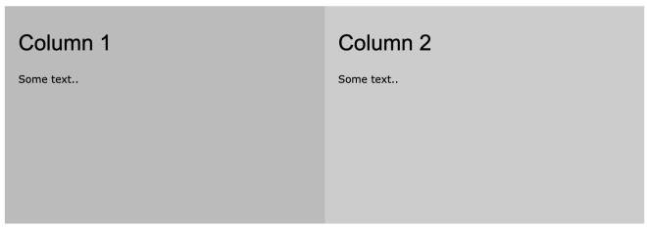

Ans

<!DOCTYPE html>

<html>

<head>

<meta name="viewport" content="width=device-width, initial-scale=1">

<style>

*{

box-sizing: border-box;

}

.first{

float: left;

width: 50%;

padding: 10px;

height: 300px;

}

.second{

content: "";

display: table;

clear: both;

}

</style>

</head>

<body>

<h2>Two Equal Columns</h2>

<div class="second">

<div class="first" style="background-color:#aaa;">

<h2>HTML</h2>

<p>HTML (HyperText Markup Language) is the most basic building block of the Web. It defines the meaning and structure of web content. ... HTML uses "markup" to annotate text, images, and other content for display in a Web browser.</p>

</div>

<div class="first" style="background-color:#bbb;">

<h2>CSS</h2>

<p>CSS stands for Cascading Style Sheet. CSS can format the document content(written in HTML or other markup language):</p>

</div>

</div>

</body>

</html>

Q5: Create the below layout using Flexbox:

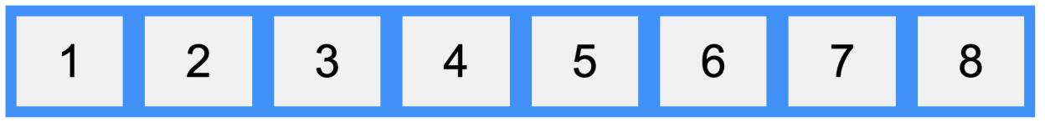

Ans

<!DOCTYPE html>

<html>

<head>

<title>Question5</title>

<style >

.container{

display: flex;

flex-direction: row;

justify-content: space-around;

align-items: center;

background-color: dodgerblue;

}

.item{

background-color: #f1f1f1;

margin: 20px;

padding: 40px;

font-size: 50px;

font-weight: bolder;

}

</style>

</head>

<body>

<h1>flex</h1>

<div class="container">

<div class="item">1</div>

<div class="item">2</div>

<div class="item">3</div>

<div class="item">4</div>

<div class="item">5</div>

<div class="item">6</div>

<div class="item">7</div>

<div class="item">8</div>

</div>

</body>

</html>

Q6: Create the below layout using Grid:

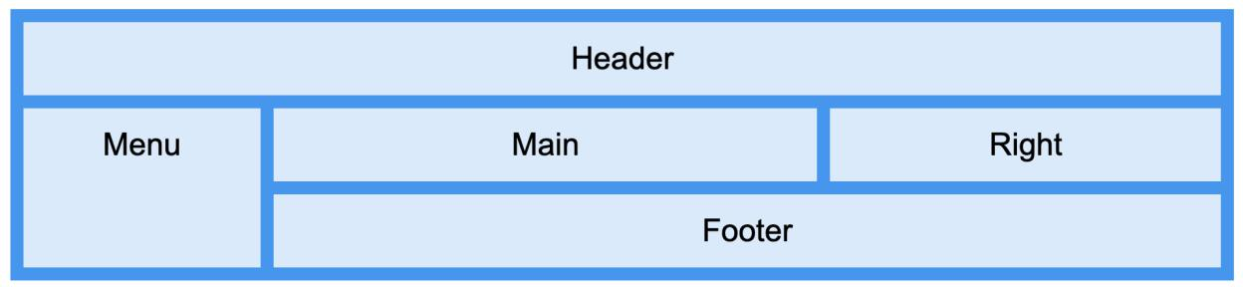

Ans

<!DOCTYPE html>

<html>

<head>

<style>

.item1 { grid-area: header; }

.item2 { grid-area: menu; }

.item3 { grid-area: main; }

.item4 { grid-area: right; }

.item5 { grid-area: footer; }

.grid-container {

display: grid;

grid-template-areas:

'header header header header header header'

'menu main main main right right'

'menu footer footer footer footer footer';

grid-gap: 10px;

background-color: #2196F3;

padding: 10px;

}

.grid-container > div {

background-color: rgba(255, 255, 255, 0.8);

text-align: center;

padding: 20px 0;

font-size: 30px;

}

</style>

</head>

<body>

<h1>Grid Layout</h1>

<div class="grid-container">

<div class="item1">Header</div>

<div class="item2">Menu</div>

<div class="item3">Main</div>

<div class="item4">Right</div>

<div class="item5">Footer</div>

</div>

</body>

</html>

Outputs

